***Project 5 Final Version UML***

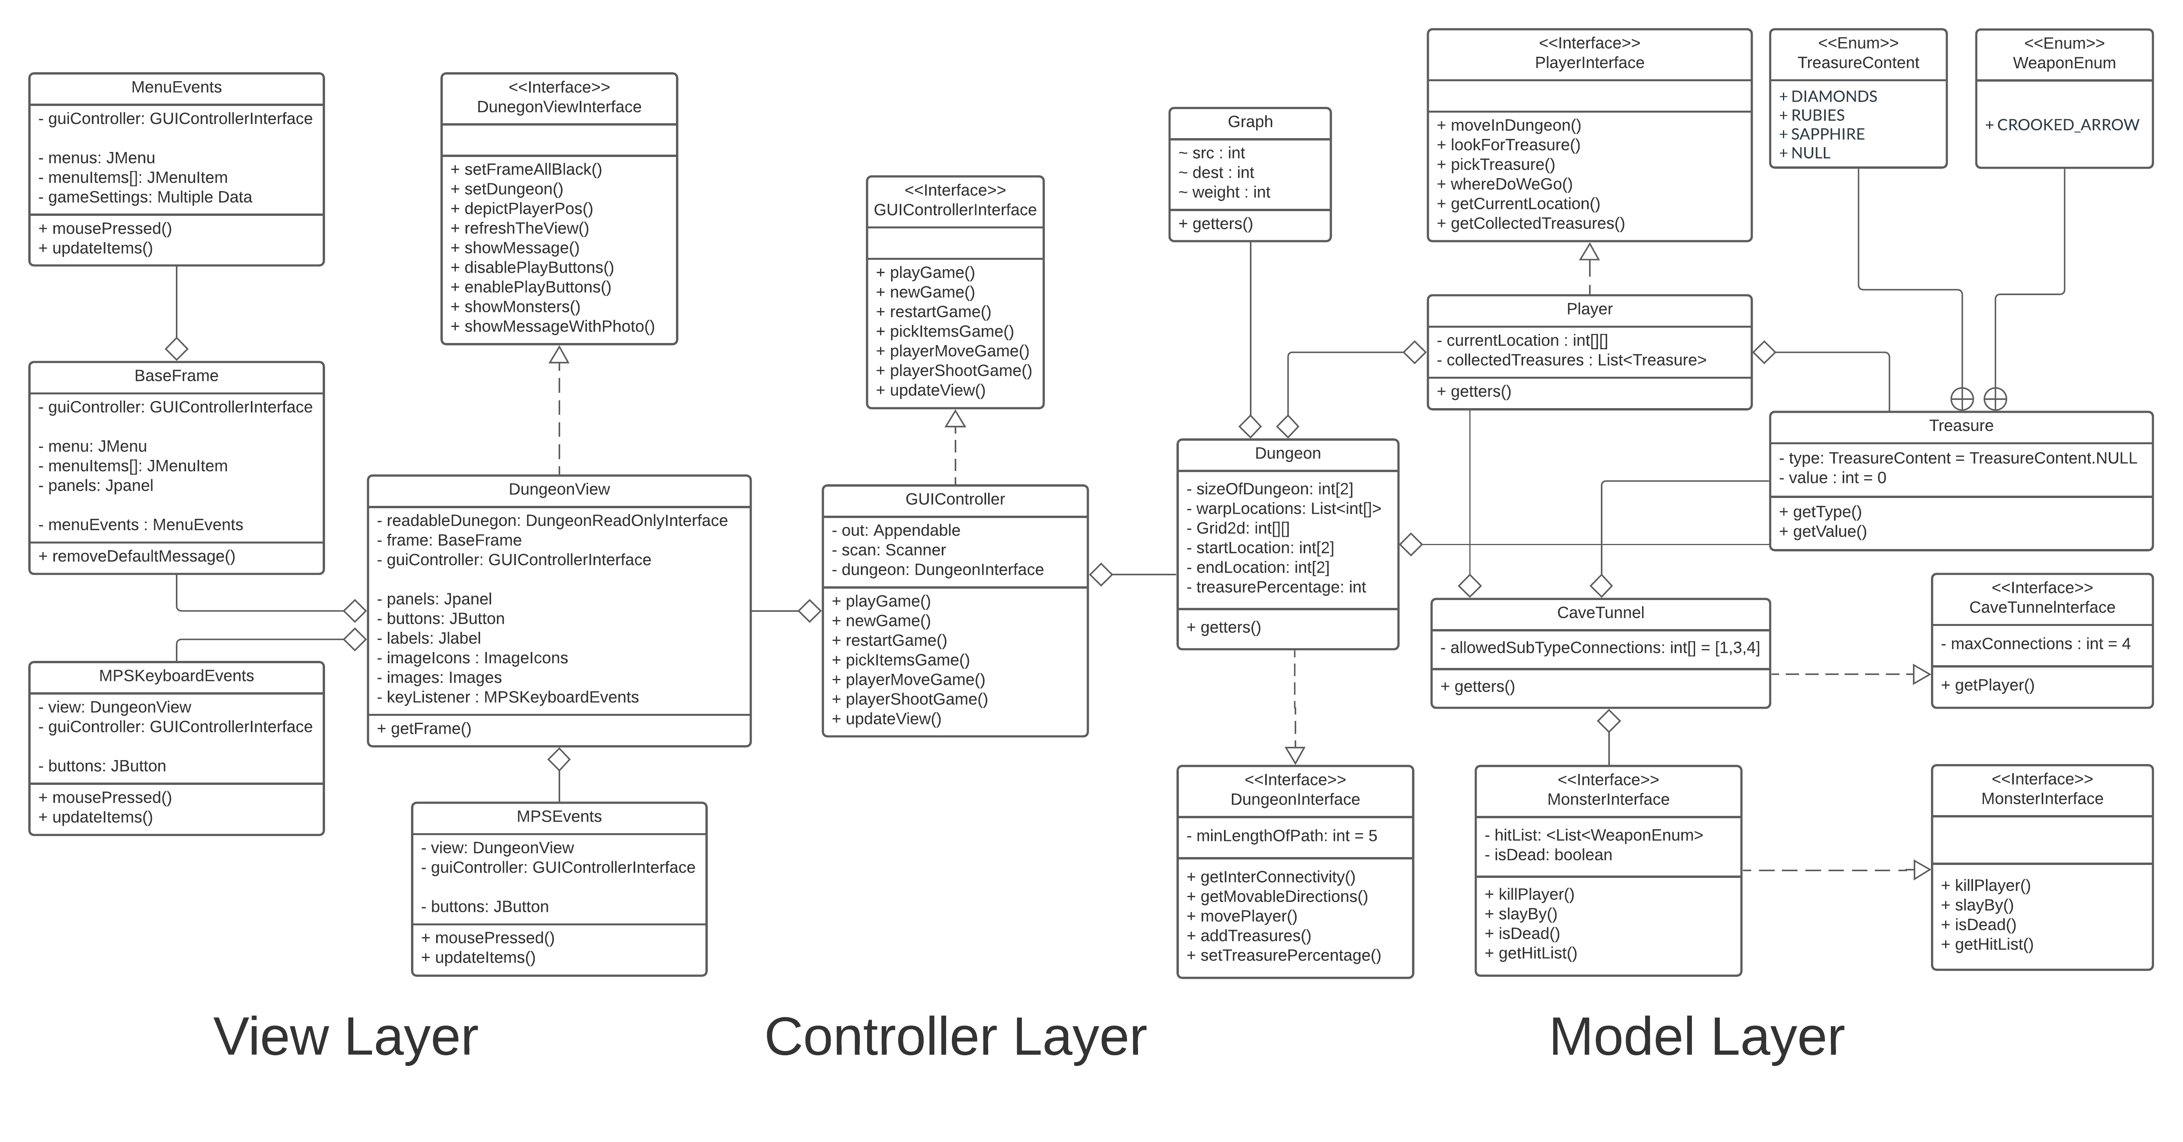

***Project 4 Final Version UML***

***ScreenShots***

***Rough Sketch***

***Basic Testing Plan***

1. Create Dungeon object, with desired size (Rows x Columns), assign treasures to whatever percentage you like.
   1. Check whether the correct sized dungeon is created.
   2. Check whether total treasures match (with tokerance) the amount of percentage of setting up treasures given to it .
   3. Print the state of dungeon.
2. Create Player.
   1. Check whether the player is created as per the given params/conditions.
3. Create a Cave and a Tunnel.
   1. Check for whether they can hold treasure or not.
   2. Check whether they can hold monster or not.
   3. Check whether they can hold weapons or not.
4. Add player to Dungeon.
   1. Check whether it can look for treasure or not.
   2. Check if treasure is there, it can pick it up or not.
   3. Check for whether dungeon can move player or not.
5. Create a Treasure.
   1. Check whether it only allows values from enum to accepted.
6. Create Monster.
   1. Check whether the monster can kill player or not.
   2. Check whether player can slay the monster or not.
   3. Check whether monster is reportiing alive/dead status.
7. Create Controller.
   1. Check weather it is taking right input and passing right output.
   2. Check weather it is terminating the game correctly or not.

Further Testing can be done as soon as any condition, expression, functionality is added whilst implementation of the requirements.